**Lab 2**

**Lab conditions:**

This lab exercise to be completed by the end of the class. No late submission will be accepted.

Work as group of two students or individually.

Submit a Word document file or a PDF file on D2L at Activities >> Assignments >> Lab2.

Make sure your following naming format as listed below:

Last name, First Name: ____Afonso, Markus____ Student ID: ____A01333486______

**Questions:**

1. Research, discuss Explain the purpose of different personal computer (PC) hardware components. Make sure to address all the aspect of the topic.

There are usually 7 main components within a personal computer:

1. CPU (Central Processing Unit) – the main processing within a computer, acts like the brain
2. Motherboard – where everything is plugged into, connects all components of a computer
3. PSU (Power Supply Unit) – provides power
4. Primary Memory – can be referred to as RAM, holds data for the CPU to process
5. Hard Drive – storage for the computer, this is where all programs and applications exist
6. Input/Output Devices – example: keyboards, mice, and monitor – necessary to interact with the computer
7. Expansion Cards – these can come in many forms from a graphics processor to an internet card

2. What’s lossless compression? What’s lossy compression?

Lossless compression is a type of data compression where the size of data is reduced without losing any of the original data. In other words, if a file is compressed using lossless compression it can be fully restored to its original state

Lossy compression is a type of data compression where unnecessary data is deleted to reduce the size. This is often used to reduce the size of images. Pixels that a human eye can’t make out are deleted to save space. Unlike lossless compression, lossy compression cannot be restored to its original state.

**3. Desktop Computer DIY**. Suppose you decide to build a desktop by yourself and your budget is around $1000 (without OS). Discuss with your team members and list all the parts and tools you have to purchase with price. List the technical Details and explain what your desktop will be used for, such as listen to music, word document, 3D design, software development, watch movie and so on.

* Intel Core i5-11600K - $179.99
* be quiet! Pure Rock 2 Black CPU Cooler - $49.99
* Asus PRIME B560M-A Micro ATX LGA1200 Motherboard - $109.99
* Corsair Vengeance LPX 16 GB (2 x 8 GB) DDR4-3200 CL16 Memory - $53.99
* Samsung 970 Evo Plus 1 TB M.2-2280 NVME Solid State Drive - $107.24
* MSI Radeon RX 6600 XT 8 GB - $329.99
* NZXT H510 ATX Mid Tower Case - $74.99
* EVGA G5 650 W 80+ Gold Certified Fully Modular ATX Power Supply - $69.99

Total:

$996.17

I think this computer is more than capable of nearly all tasks. The Intel Core i5-11600K would make quick work of any 3D design or software development, and the MSI Radeon RX 6600 XT is more than enough for any photo editing or video rendering.

4. Download and run CPU-Z. Paste your screenshots (technical details) below.

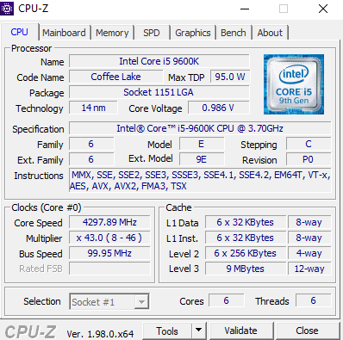

5. Review PPT for Diagnosis problems, make an example or make your own notes

A diagnosis problem that I have had in the past is faulty RAM. The issues caused common BSODs and because it was the RAM it was nearly impossible to recreate and find the issue. Because of its randomness I knew it wasn’t the CPU or GPU causing the issues so I figured it was either storage, RAM, motherboard or the PSU. Not wanting to replace any parts before I knew what was causing the problem, I did a Crystal Disk benchmark to test the storage. It returned a valid test, so I tried doing a MEMTEST off a USB. After running the test overnight, it returned an error, and after replacing the RAM the issue was resolved.

6. **Challenge Question**

Consider the hypothetical machine:

Instruction Format: 16 bits (bits 0 to 3 for the opcode; 4 to 15 for the address).

Integer format: 2’s complement on 16 bits.

Partial list of opcodes:

0001 Load AC from memory

0010 Store AC to memory

0100 Add AC and R1, result will be in AC

0101 Add to AC from memory address

0111 Load register R1 from memory

0110 Load AC from I/O

1000 Store AC to I/O

1001 Move R1 to AC

Consider that the memory address (7A9)H has the contents 16 in decimal represented in 2’s complement; memory address (7AA)H has contents (-11) in decimal represented in 2’s and the program starts at address (B2F)H. The address is word addressable (1 word = 16 bits).

Consider the following program:

Load R1 from memory address 7A9H 🡪 1100 0000 0001 0000 - 77A9

Move R1 to AC 🡪 1001 0000 0000 0000 - 9000

Load R1 from memory address 7AAH 🡪 0111 1111 1111 0101 – 77AA

Add AC and R1🡪 0100 0000 0000 0000 - 4000

Store AC to address 7ABH 🡪 0010 7ABH – 27AB